Isla Covarrubias
Professor Marino
HUM 196
April 24, 2020
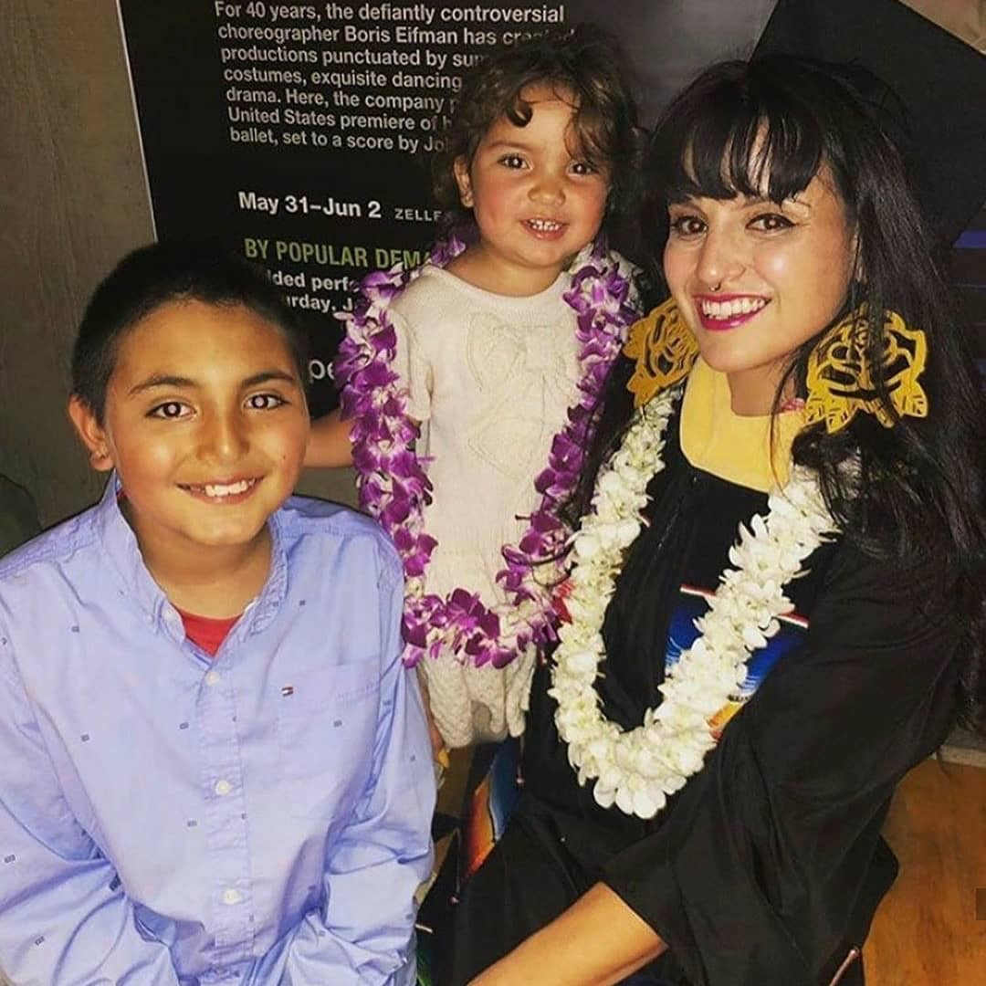
In loving memory of Sylvia Bracamonte

Life After Graduation: What About Now?

Abstract
Moms4Housing has highlighted the displacement of its community and the lack of affordable housing for recent college graduate parents. College graduates with dependents and marginalized communities are at the forefront of the current homeless population that has skyrocketed in the state of California. While the topic of homeless affects the whole state, this document focuses on Alameda County. The focal point of my research is mainly based on the campaign of Moms4Housing, located in the same county as the University of California, Berkeley. I argue that the conjunction of these two factors mainly focuses on UC Berkeley as the one to produce graduates with dependents with an unaccessible housing market creates a vulnerable population. I go on to touch upon a recommendation that can benefit the private sector such as real estate, and UC Berkeley and Moms4Housing as the public sector to promote a fellowship as the possibility to target and benefit such a population. I go on to include a policy that benefits society, the public sector and the private sector. This proposition will give each party the power to benefit from each other, while providing a well rounded future not only for the recent graduates, but also for the state, and the public sector.
A Brief Reflection

This research emerged from a conversation I had with other student parents, highlighting the emergency behind a program that can ease students' parents back into society. This idea of transitional housing stuck in the back of my mind and continues to reemerge from time to time. While transitional housing stuck with me, I started working in another project. Being part of the Brown Issues UC Berkeley chapter, allowed me to do outreach for marginalized mothers. Three other student mothers and I piloted an informational presentation to allow community colleges student mothers and teen mothers in continuation schools to reimagine their lives within the possibilities of higher education. The demand of this outreach program exploded and we were well received in those spaces. So when this research opportunity came into my hands, I saw a way to bridge transitional housing with an outreach program to become a fellowship program for Cal Alumni student parents. As I started to carry on with this research our present change, becoming an unknown reality, due to Covid-19. This is to say that life for humanity changed abruptly worldwide, providing the feeling of life itself coming to a complete stop. Just like life changed, my research methods did as well. Instead of having interviews, I have to restructure my methods so I can continue with my research without coming in contact with anyone. I decided to do archival research by looking into websites, photos, books, and laws in order to think of an utopia world and a policy that can reshape our current world with a positive impact to Cal Alumni with dependents.
Introduction
As a current Cal student, I have realized that my time at Cal is coming to an end, and the cost of living in the market has skyrocketed. I know that as a student parent I'm responsible for the wellbeing of my children. Working to put myself through school with my children has not been easy, but now life is suddenly much more complicated. Without family support to help bridge the transition from student housing to the rental market, the promise of a college degree has failed to sort things out. Due to such limitations recent Cal student parents are forced to move back to the same low-income neighborhoods where they had escaped from. As I voiced my worries, I was able to witness other student parents second my thoughts and concerns. Through my research I came across families who had faced housing difficulties after graduating from college and working multiple jobs without being able to properly protect their children.
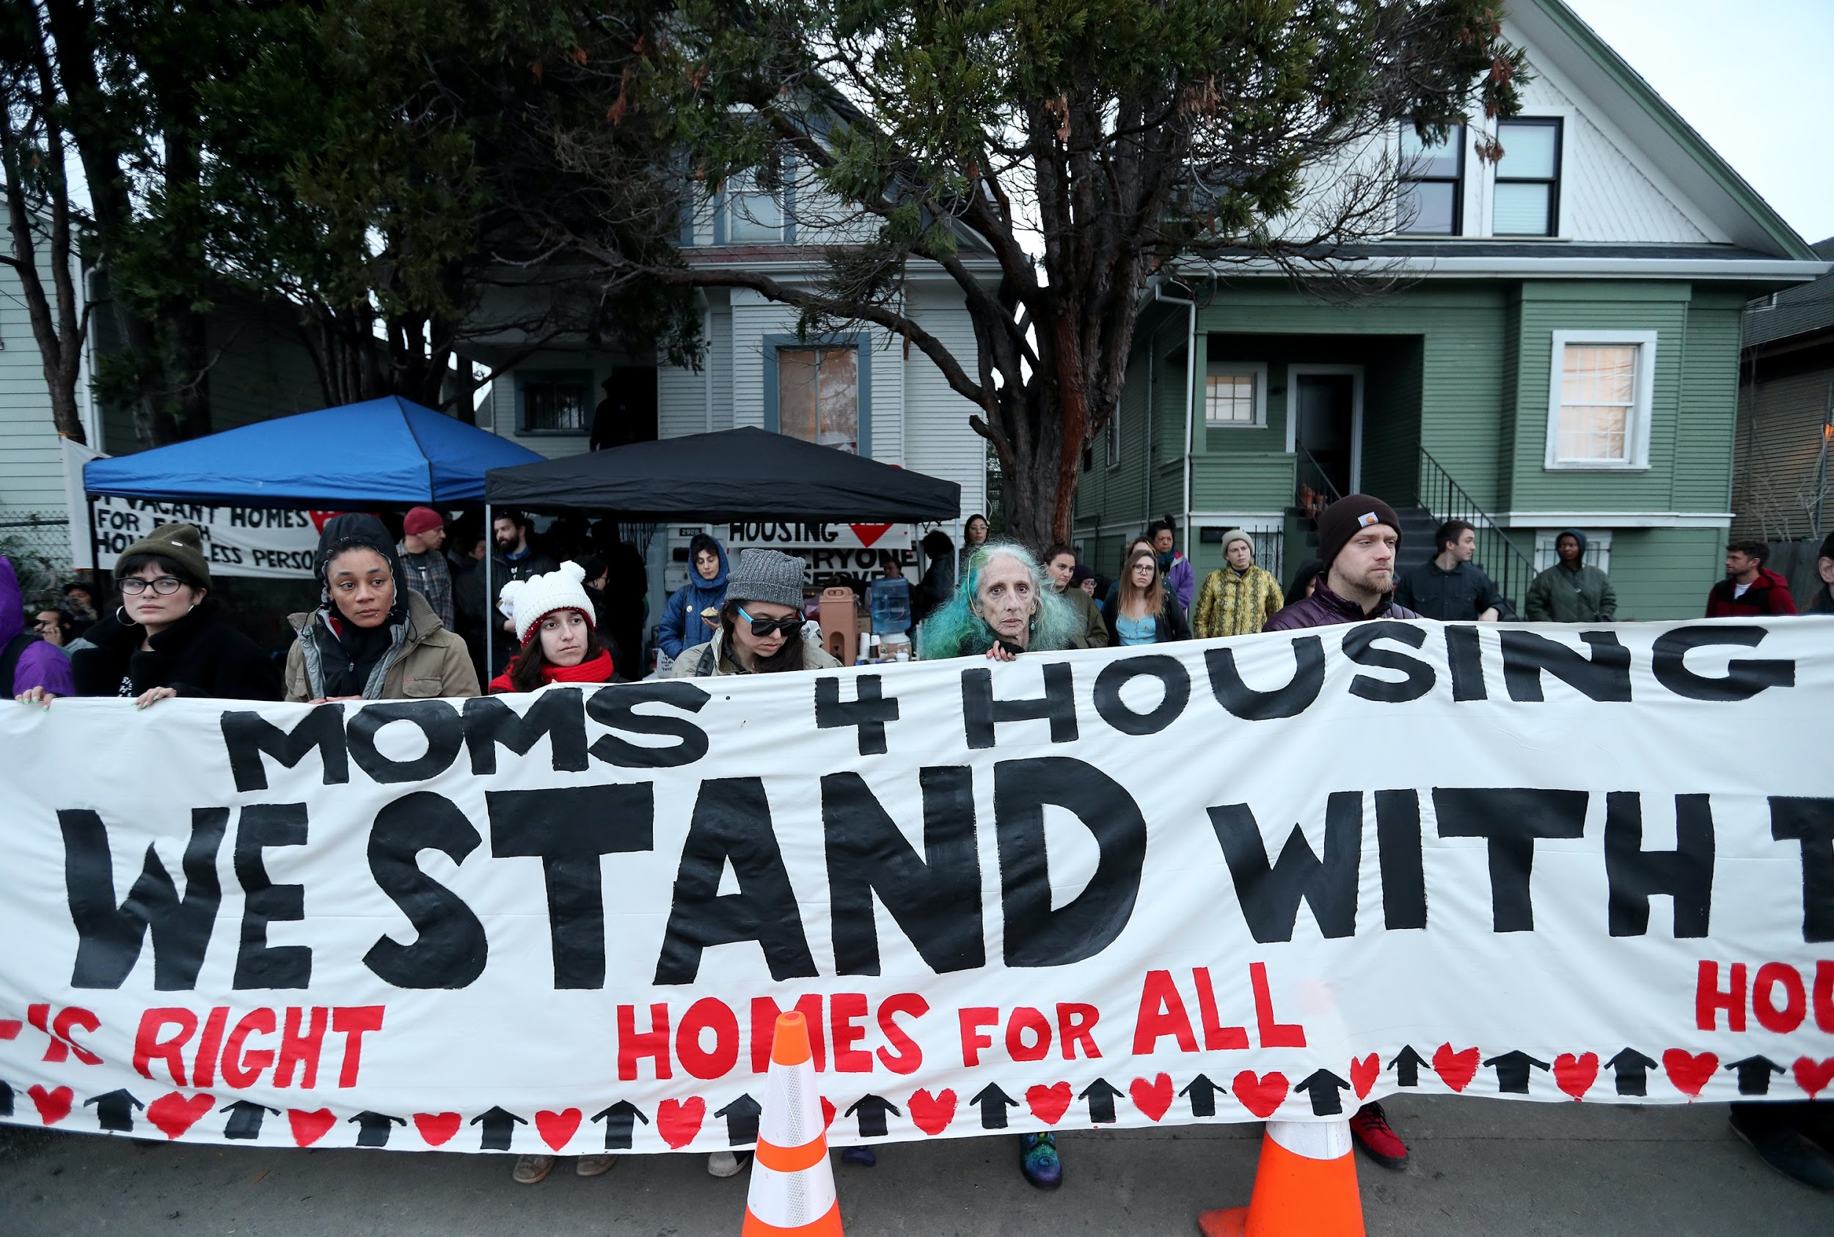
While my concerns about housing have been forefront in my mind, it was increasingly apparent that I was not alone in this struggle for decent housing. This same concern is seen among my peers, who are about to graduate and those who have already graduated. Consequently, I further my research to the community and I came across a city-wide and later mass movement of Moms4Housing. These very real concerns for me made the headlines in ways that challenged the very organizational basis of property, debt, and economic shut out that mothers like me were experiencing every day. Dominique and Sameerah, both young professional mothers in need of housing, stood up against the severely inadequate conditions that have increasingly pushed out people of color and the poor. These two mothers were able to find allies among people in the community and Wedgewood properties. After occupying a home that had been in the real estate market and unoccupied for a period of eighteen months, these two mothers were able to attract nation-wide media attention. Dominique and Sameerah came to highlight inequality of housing currently existing for low income communities across California.
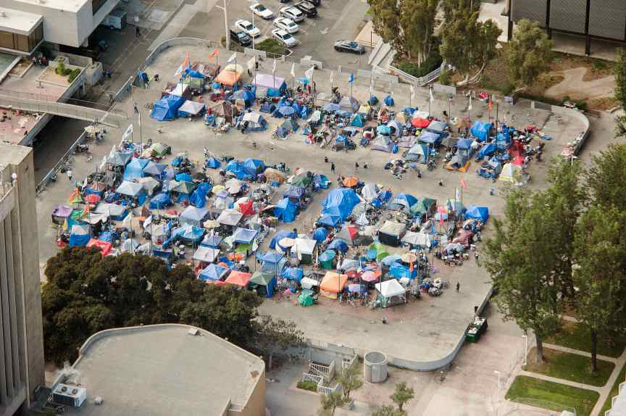
Santa Ana California homeless camps, picture taken by LA Times News paper
Homeless Statistics
Dominique and Sameerah, the founding members of Moms4Housing, staged their actions in order to fight for their right to shelter. These mothers made a heroic act by occupying a home that has been for sale for over eighteen months by a private company (Wedgewood Properties, 4/30/2020). These mothers were able to attract media attention as they voiced the inequalities surrounding housing. Dominique and Sameerah showed how they became part of the homeless community after graduating from college and relocating to their hometown. Once in Oakland California, they were faced with the cruel reality of not being able to pay the disproportionate cost of housing, as they became homeless, but isn’t it “housing a human right?” (moms4housing.org, 5/1/2020).
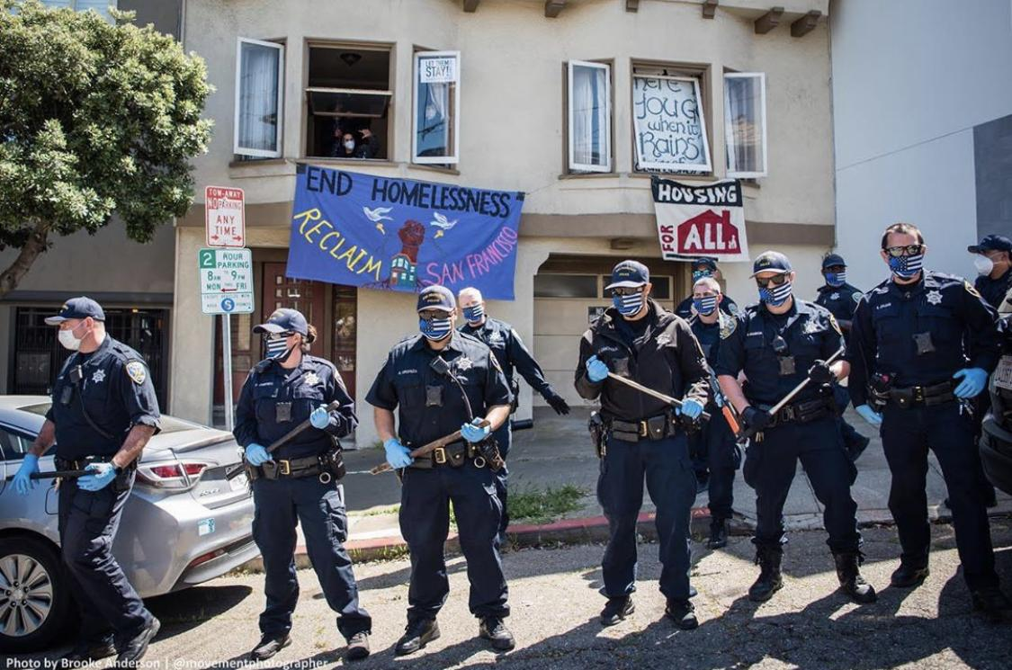
As many activists and scholars have shown, the cost of housing displaces low income communities while more privileged communities buy overpriced houses lost by previous residents. Low income communities are being affected all over the Bay Area, causing a massive growth of the homeless population. In Alameda County, “the number of homeless people countywide rose 43%, from 5,629 in 2017 to 8,022 in 2019” (San Francisco Chronicle, 4/25/20). In just two years thousands of new people, families like mine, were forced into the homeless population.
Homelessness is disproportionately affecting the African American community. Especially since this community makes up 50% of the homeless population currently existing in Alameda County (San Francisco Chronicle, 4/25/20). Finding affordable housing is a growing problem for low income communities all over California, but for people of color, shelter, the home itself, is an ever more futile promise representing the inequities baked into the foundation of our political and economic systems. Democracy, in this paper I will define it, as a system shaped by one’s ability to function in society with a place to live and presumably prosper, is a failed promise for people of color, for student mothers like me, and for everyone who participates in an unequal system that benefits from the displacement of others. While these problems are certainly community wide, for the purpose of this paper I will be highlighting the needs of recent student parent graduates. 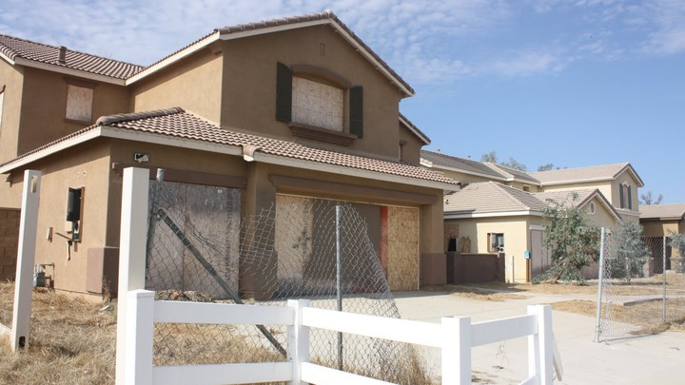

Current Home Conditions on the Market
Moms4Housing states that per every homeless person there are four to five houses available. In other words, Moms4Housing understands the possibility of finding affordable housing for low income families, despite understanding that this shelter is found in inadequate conditions. Another concurrent problem in Alameda County is the need to rehabilitate 12% of units built during 1990, which are in need of repair. This 12% represents 56,270 units that have been taken off the market. In addition to the number of units that need some type of repair, 5% of these available units need to be replaced, making 2960 units ready for demolition (acgov.org, 22). All over California, houses are found unoccupied while families are struggling to pay high prices. It is exactly what happened to Moms 4 Housing, when they found themselves struggling to find affordable and safe shelter. These mothers came across a home that was unoccupied and needed multiple repairs. As they took over the house, they were able to fix it up to be a livable
place.
Ripple Effect in California
Consequently, Moms 4 housing has become a ripple effect, as it has guided other mothers all over California to reoccupy vacant houses and make them into homes. In the area of Los Angeles, a group of mothers were forced to seek shelter due to the world epidemic of Covid-19. Simultaneously, the Los Angeles Times reported that many of the houses in the Los Angeles area have been empty for more than 35 years (Los Angeles Times, 4/20/2020).
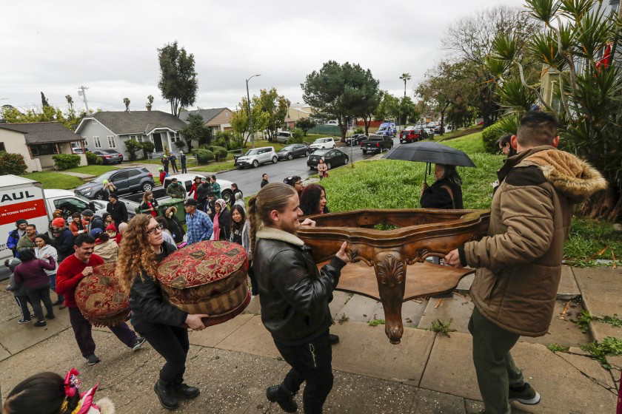
Volunteers help move Martha Escudero into a vacant house she and other protesters occupied Saturday morning. (Irfan Khan/Los Angeles Times)

It is important to know that many of these houses had been property of the state, these houses have been bought with the intention to expand the 710 freeway. This project never took place and the house remained unoccupied for 35 years. Due to global pandemic Martha Escudero and Ruby Gordillo were pushed to seek shelter out of one of the homes previously planned to extend the 710 freeway as squatters, a term used to identify those who decided to occupy a land or house that does not legally pertain to the individual (leginfo.legislature.ca.gov, 5/3/2020). In the emergency of preventing themself and their children from getting contaminated by coronavirus they took shelter as an action of their democracy and human rights.
Los Angeles just like the Bay Area has been battling with homelessness and affordable housing for quite some time. These mothers have acknowledged that affordable housing is a major problem in the state of California. With the intention to benefit others they wrote to Governor Newson so they could start a plan that can meet in the middle with the state and constituents who have been affected by the price of housing. Affordable housing has become a recurrent problem for low income communities all over California, therefore, it is important to think of new policies that can address such problems. I am talking of policies that can assess the community in order to address unfinished projects such as the one in the area of Los Angeles. Where houses had been bought to be demolished so a freeway can be widened, but this never happens. Now is the time to flip from an unfinished project into an affordable housing community. Having organizations such as Alliance of Californians for Community Empowerment and a combination of current legislation to assist achieve affordable housing.
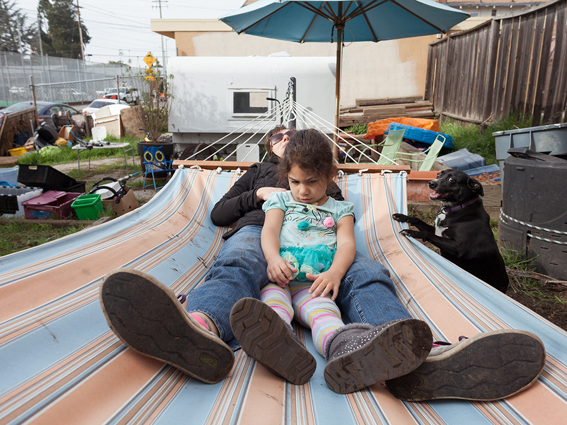California’s Housing Crisis Is So Bad, Families Are Squatting Abandoned Homes Just to Survive
Activists are pioneering a bold—and possibly legal—way to combat the housing crisis. TEXT BY BRYAN SCHATZ; PHOTOGRAPHY BY MCNAIR EVANS

Questions

Due to the concurrent problem of affordable housing I ask might student parents replicate the action of moms 4 houses across California?
How can student parents reoccupy empty houses owned by the private sector or the state that have been on the market for more than twelve months?
Utopian Future: A Policy for a Change
There are a couple of ways this question can be addressed. The path that I will be taking is through the creation of new policy, reinforcing democracy and focusing on affordable and transitional housing for recent student parents graduates. As one might have noticed, homelessness is a growing population, and education without opportunities reinforces the poverty cycle. For that reason, a transitional program for student parents needs to be in place so these groups of individuals can have the ability to participate and function in democratic society that can provide an equitable system. First, this program needs support from the private and public sector. The support from the private sector is going to focus on those real estates that have had a house in the market for more than twelve months. In combination with this policy, real estate will lease their houses for one-year period to recently graduated student parents. Secondly, such a program will work in conjunction with the University of California, Berkeley. The university will provide families who can participate in such programs. Especially since those students have been residents at University’s property such as the University Village. Allowing the University to provide responsible and clean tenants. Thirdly, this program will be a network component. By being able to work closely with the university, it will allow students to use their resources and networks to seek employment. This is a policy that can bring monetary relief to the private sector by tax cuts as well as adding monetary components when renters pay their rent at an affordable price.
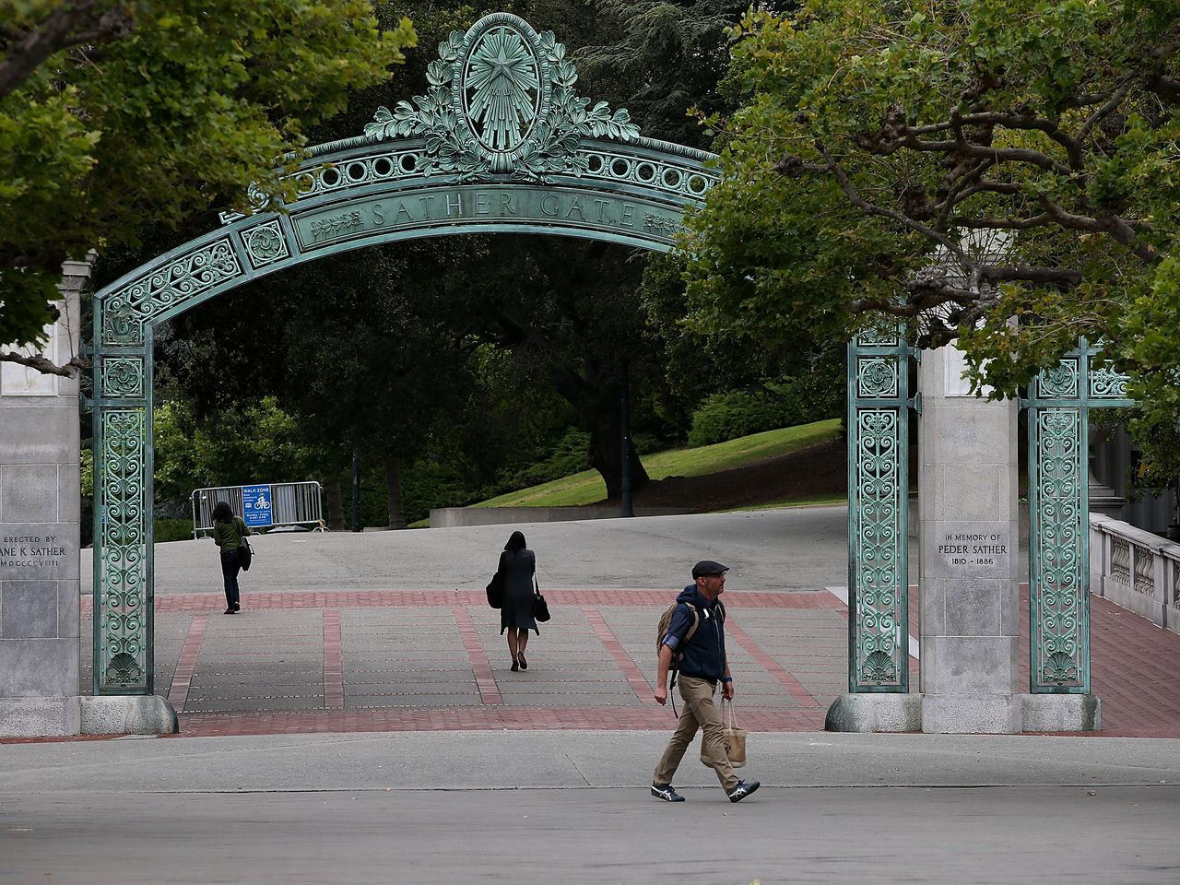
Another component of this policy would be UC Berkeley providing adequate residents for the property. One way to funnel our student parents can be through a post-bachelor program that Cal alumni students would be able to apply. This program will include family housing and employment. The idea behind this is to replicate what Moms4Housing has today, such as the access to affordable housing and a possibility to build a network that can connect professionals all over California. By having the private sector incorporated, they can offer their jobs and in exchange CAL students are equipped for any challenge that the workforce can bring. This will be accessible to recent graduates who are able to utilize the network that can provide various points of employment to first generation and low-income graduates.
Conclusion
To conclude, evidence throughout my analysis was piled together with various statistics and sources to highlight the necessity of affordable housing for recent graduates and professionals. In like manner understanding the essential necessity of poor communities of color that have been disproportionately affected brings into life the necessity of individuals such as Moms4Housing. I was able to conquer this by demonstrating the current gaps in our security net, by taking into consideration the growth of homelessness, the growing percentage of vacant houses, and the current global pandemic. Moreover, it has exposed great gaps in democracy, and who it serves. Therefore, creating new policies with the conjunction of the work of multiple organizations from the private and public sectors can construct a legal movement to a more inclusive policy. This will create a change on the process of transition between academics and into the world. https://spark.adobe.com/page/10iYC7TmN6HtM/

Works Cited

Dillon, Liam & Nelson, Laura J., “Another Group Of Homeless Mom and Families are taken
Over a House - This time is L.A.” Los Angeles Times. 2020.
<https://www.latimes.com/homeless-housing/story/2020-03-14/homeless-moms-occupy-house-los-angeles-caltrans-coronavirus-pandemic>
Of the Time of Commencing Civil Actions (Amended by Code Amendments 1873-74, Ch. 383.)
<https://leginfo.legislature.ca.gov/faces/codes_displayText.xhtml?lawCode=CCP&division=&title=2.&part=2.&chapter=2.&article=>
“Population, Household and Housing Characteristics” West Oakland: Community Information

Book 2001. Alameda County Public Health Dept., 2001.

<https://www.acgov.org/cda/planning/generalplans/documents/2003-housing_element/populationhousingelement.pdf>

Ravani, Sarah “Oakland homelessness surges 47% - per-capita number now higher than SF and

Berkeley” San Francisco Chronicle. 2019.

<https://www.sfchronicle.com/bayarea/article/Oakland-homelessness-surges-47-per-capita-14115123.php>
Schatz, Bryan “California’s Housing Crisis Is So Bad, Families Are Squatting Abandoned
Homes Just to Survive: Activists are pioneering a bold—and possibly legal—way to
combat the housing crisis.” Mother Jones. 2018.
<https://www.motherjones.com/crime-justice/2018/04/retake-the-house/>
Trevor Mells, HMIS Team Lead “EveryOne Counts! 2019 Homeless Count and Survey”
Housing Instability Research Department (HIRD), 2019. Alameda County Homeless
Count & Survey Comprehensive Report 2019.
<https://www.fremont.gov/DocumentCenter/View/41808/Alameda-Homeless-Survey-2019>

